**Database Final Project worth 30%**

You have been hired to update and maintain an existing database. The database contains 3 tables with student, school and mark information.

PLEASE NOTE** This project is based on you selecting unique data and values throughout. Ex. names, data placements etc. **DO NOT** **share your file.**

1. Open the **Final Project Start File** and review the contents. Create **6 new entries** of your choosing in the **Student Information** table. Make sure you enter data in **all** the fields. Include your own name as one of the entries.

**(3 marks)**

2. Create **2 new fields** in the **Student Information** table.

After the School Name field, create the first new field called **Pictures**. The datatype will be **OLE Object**. Add pictures for **all** the entries. Pictures for the Initial database have been provided. **You will have to find pictures for your new entries.**

Insert the pictures (.jpg files) in the Pictures folder to match the Students name. Make sure to add pictures for your new entries.

**(3 marks)**

After the Picture field, create the **second new field** called **Additional Comments** with **attachment** as the datatype. Add the attachments provided in the folder called attachments for the initial database. Insert the documents (.docx files) in the folder to match the name.

Create at least **3 new attachment entries** of your own to add to your table.

**(2 marks)**

3. **Update the Student Marks and School Information tables to** reflect your new entries in the Student Information Table. For example, if you added a new student Charlie Brown you will have to add him/her to the Student Marks table and create entries for this new student. If you have added a new school in the Student Information table, you will have to add that new school in the School Information table.

**(3 marks)**

4. Create a **One to many** relationship between the **school Information table** (one table) and **student Marks table** (many table) Enforce referential Integrity

Create a **One to many relationship** between the **Student Information** (One table) and **Student Marks** table (many) Enforce referential Integrity

Hint: Use the primary key field in the one table for your relationships. If you encounter errors that means you need to update your tables (step 3)

**(1 mark)**

5. Create a **basic report** based on the school marks table calculating the **average** of **all** **students’ marks**. Use all the fields. Call your report **Students Mark Information**. Change your title to **Average of Students Marks**. Using **Conditional Formatting** create a rule that highlights the letter grade field of all students who have received a **F** grade in **red bold font**. Make sure your report fits on 1 page (You can charge the orientation, or you can adjust the column size – your choice)

**(2 marks)**

6. Create a **Split form** named School Information Split Form, based on the **School Information table**. **(1 mark)**

7. Create the form named **Confidential** in Design View

Use the **Student Information table** as your record source to create your form. Use all your fields in your form. Format/Arrange it as you would like.

The title of your form is **Student Progress and Personal Information.** Format your title in red, the font size is 26, the font weight is semi-bold, and the special effect property is set to raised. **Feel free to format however you would like** – These are examples only. The text align property is set to distribute.

Add **5 command buttons of your choosing** to perform various actions (ex. Add new record, close form etc.) **One** of your **buttons** should open your **Student Mark Information Report** or your **School Information Table Split form**.

Change the background color of your entire form to a color of your own choosing.

Use your property sheet to change the picture field Size Mode to **Zoom**.

**(8 marks)**

8. Create the Report called **Student Information in Design View**. The record source is the Student Information table. Use all fields except for First and Last names. You will create a text box for these fields.

The Title of the Report is **Current Student Information**

**Group** by School Name. Place the school name field in the **School Name Header.**

Create a **text box** that contains an expression which includes the First Name and Last Name fields. Name the label **Students Name**

Create a **subreport** by using the fields from the **Student Marks** table displaying the fields shown below. Call your subreport Student Marks

Resize your report so each report page fits on **one-page** (You do not have any empty pages in your report) Check in print preview mode

Remove all color from your subreport so the background is white.

Add the **Page number** and **current Date** in the Page Footer section

Format all the labels as follows: Text color blue, bold and italic. The border is transparent. Again, feel free to use different colors etc.

**(7 marks)**

**Examples Report and Forms on the next pages – Do your own formatting and arranging how you would like (Reminder: your report and Forms should have 6 more student entries than the example shows)**

Student Mark Information Report

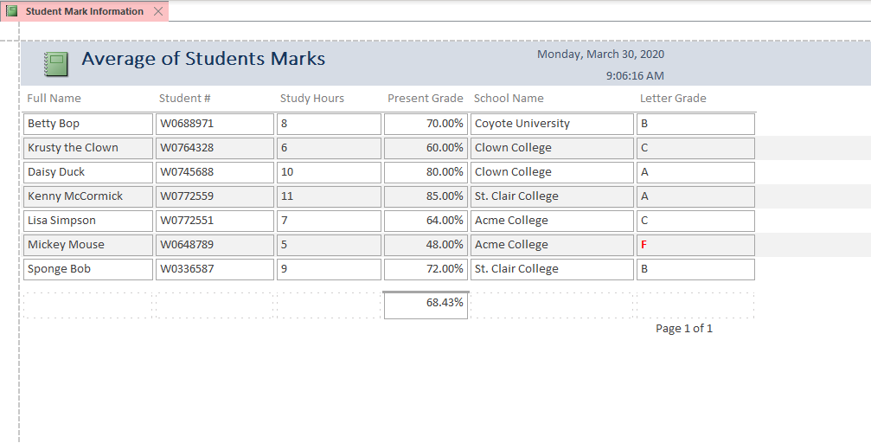

School Information Split Form

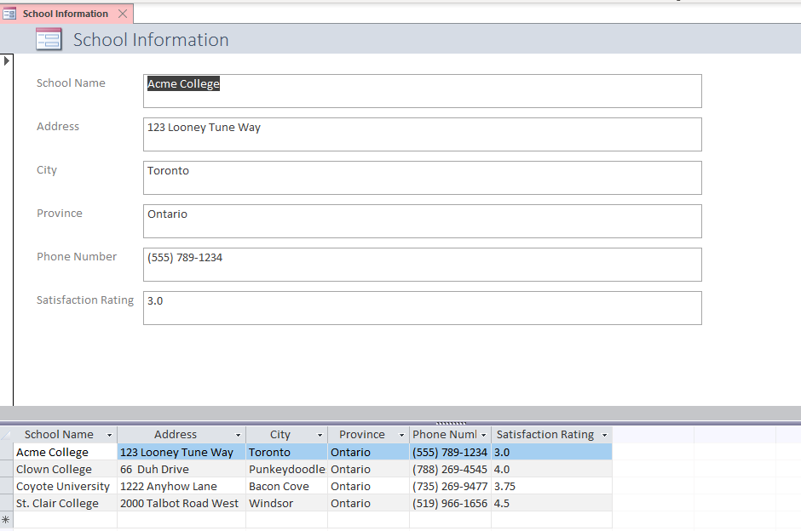

Example Confidential Form

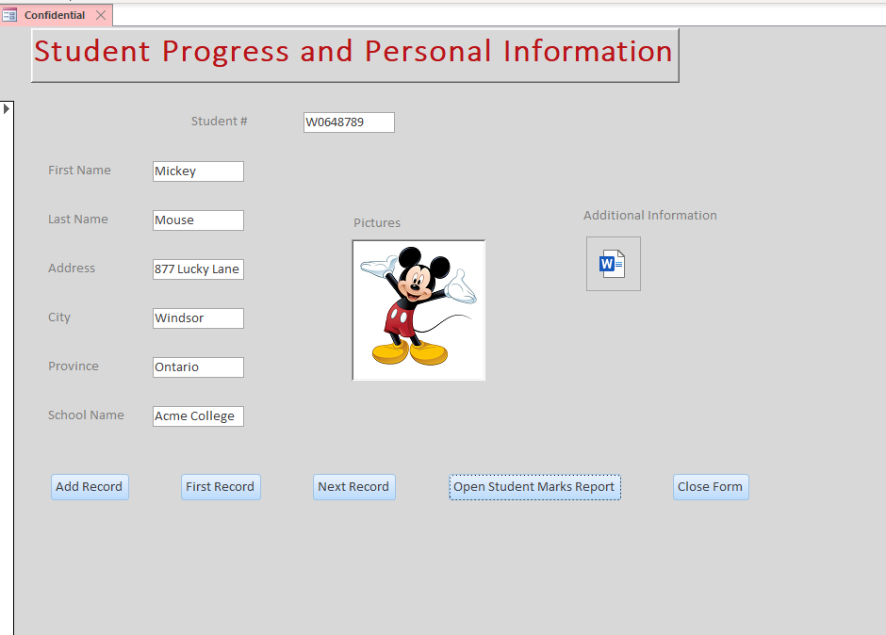

Example Student Information Report

